FREEDOM
GAMEPLAN
Build Wealth. Live Free. Reclaim Time.
● ● ● ● ● ● ● ●
● ● ● ● ● ● ● ● ● ● ●
● ● ● ● ● ● ● ● ● ● ● ● ●
● ● ● ● ● ● ● ● ● ● ● ● ● ● ●
● ● ● ● ● ● ● ● ● ● ● ● ● ● ● ●
● ● ● ● ● ● ● ● ● ● ● ● ● ● ● ● ●
● ● ● ● ● ● ● ● ● ● ● ● ● ● ● ● ●
● ● ● ● ● ● ● ● ● ● ● ● ● ● ● ●
● ● ● ● ● ● ● ● ● ● ● ● ● ● ●
● ● ● ● ● ● ● ● ● ● ● ● ●
● ● ● ● ● ● ● ● ● ● ●
● ● ● ● ● ● ● ●

Complete Resource Kit
Diagrams, Worksheets and Tools

Amir Rodnia

www.rodnia.com.au/freedomgameplan

How to Use This Kit
You finished the book. Well done.
Now here comes the part where knowing stops and doing begins.
This kit is everything you need to put what you read into practice.
It is split into three sections. Work through them in order the first time, then come back to whatever is most useful when you need it.

SECTION | WHAT IT IS | WHEN TO USE IT
Framework Diagrams | The core visual models from the book: Freedom Framework, Freedom Map, RICH Metrics, Synergification, and the Freedom Vehicle. | When you want to see the big picture quickly, or explain the concepts to someone else.
4 Stages of Wealth Building | Visual walkthrough from the Employment Trap to the Self-Sustaining Trifecta Machine. | When you want to know exactly where you are right now, and what the next stage looks like.
Worksheets and Trackers | SMART Goals, Decision Log, Freedom Ritual Tracker, and the 30-Day Kickstart. | Weekly. These turn ideas into habits and habits into results.

A note on the diagrams: print them, stick them somewhere you will actually see them, and share them with anyone who needs to understand what you are building. The Freedom Map in particular is worth spending time with. It is a diagnostic tool as much as it is a diagram.

General Information Only
The diagrams and tools in this kit are for general educational purposes only. They do not take into account your personal objectives, financial situation, or needs. Before acting on any strategy referenced here, seek advice from a licensed financial adviser, registered tax agent, or other relevant professional.
www.rodnia.com.au/freedomgameplan

01
FRAMEWORK DIAGRAMS
The visual models behind Freedom Gameplan

The Freedom Framework
The four-stage funnel that structures the entire book. Every tactic lives within one of these four layers: Think, Plan, Do, Gear Up. Start at the top. Life on your terms at the bottom.

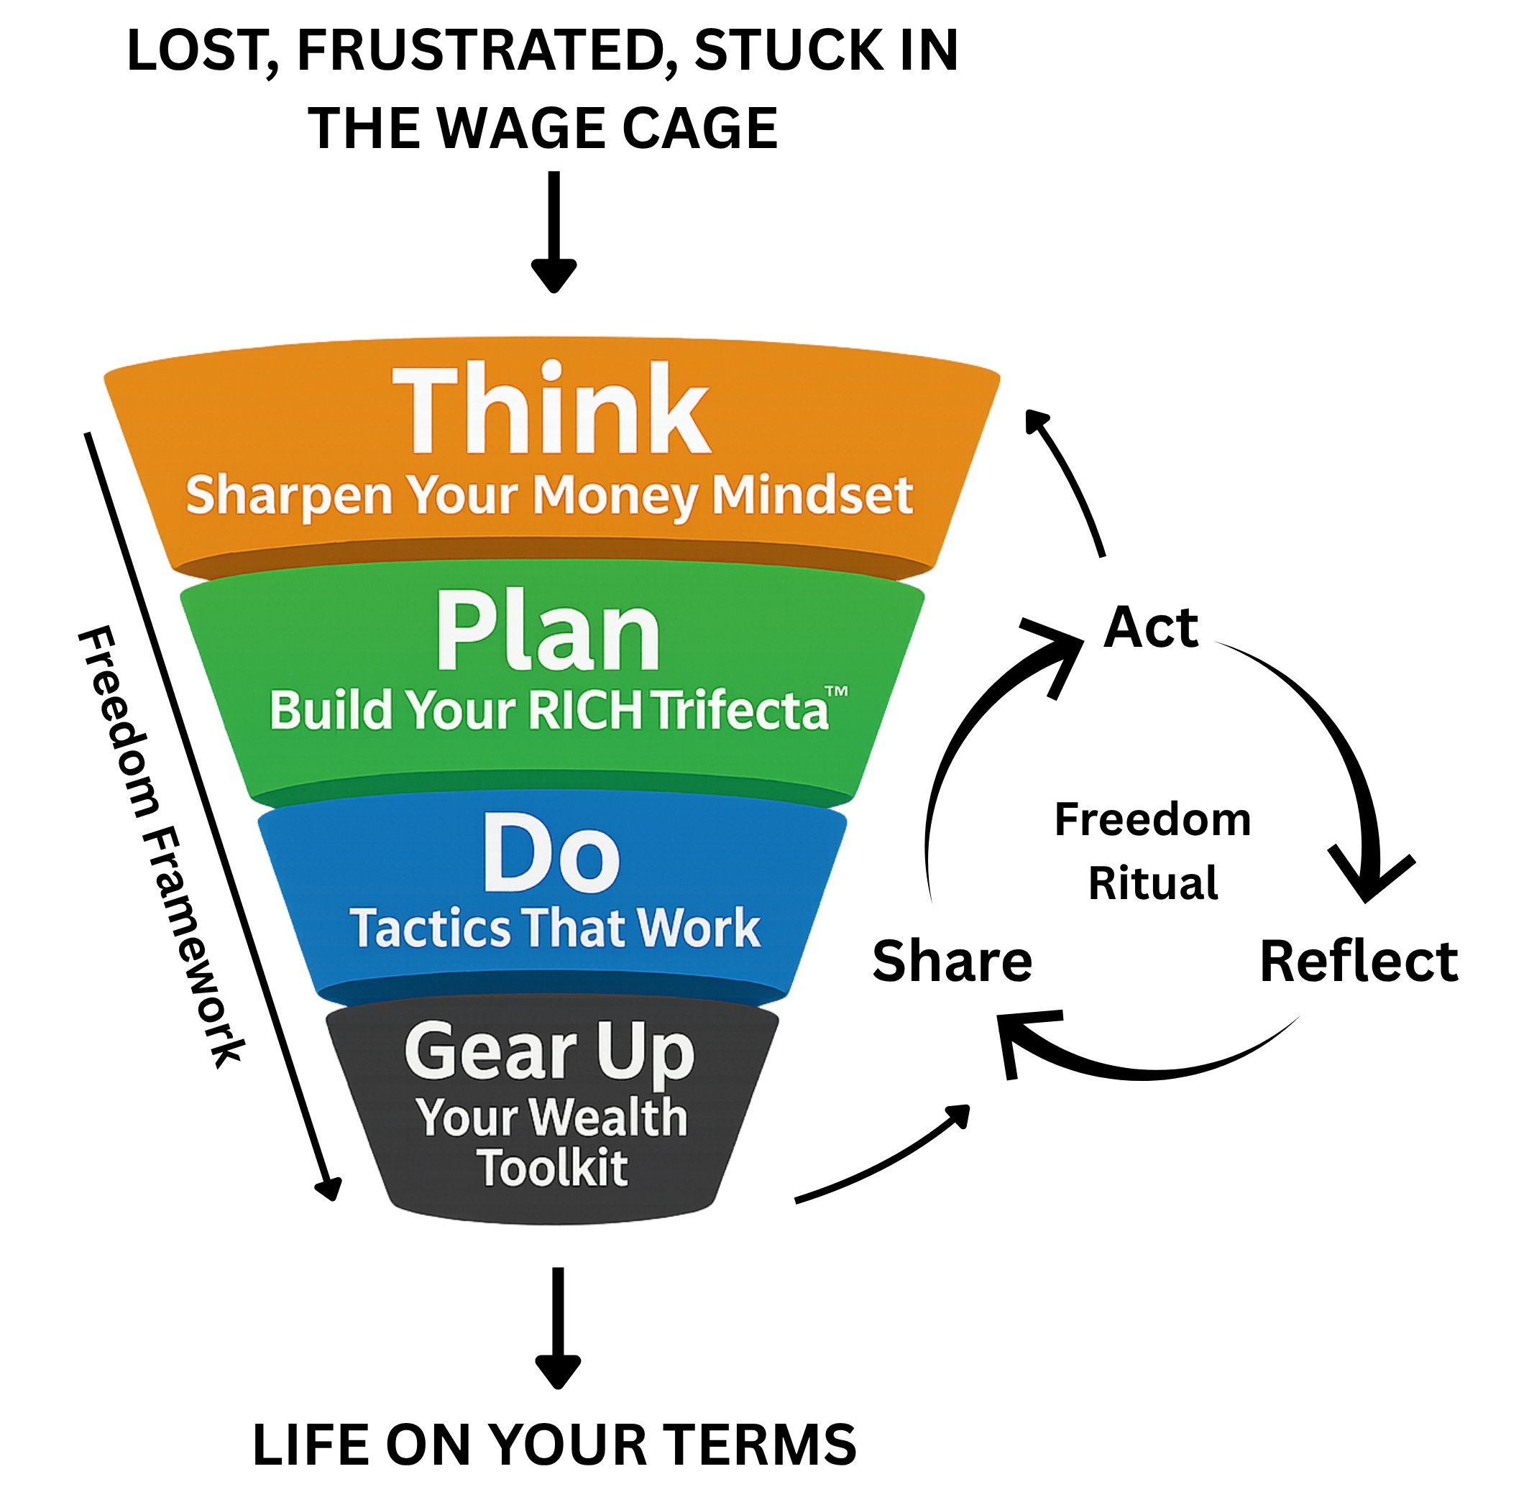

The RICH Metrics
Every investment decision in the book is filtered through four criteria: Risk, Income potential, Capital required, and Hassle. Use this when evaluating any asset class or opportunity. The ratings are relative, not absolute.
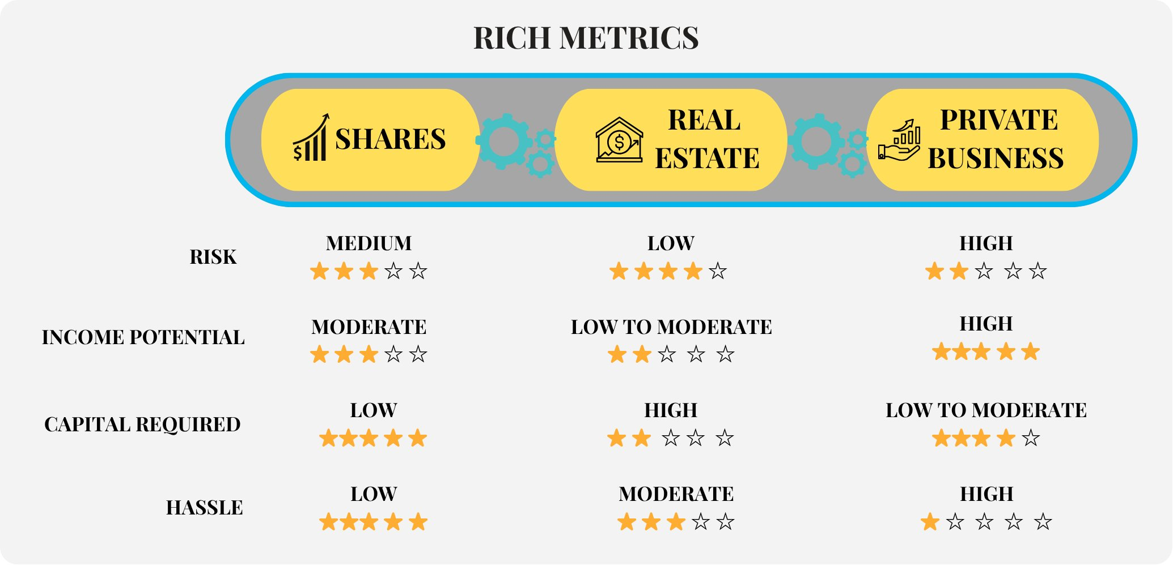

Synergification
The moment the three pillars of your RICH Trifecta start fuelling each other. Property unlocks equity that funds shares. Business cashflow buys property. Dividends support the business. When all three move together, that is Synergification in action.
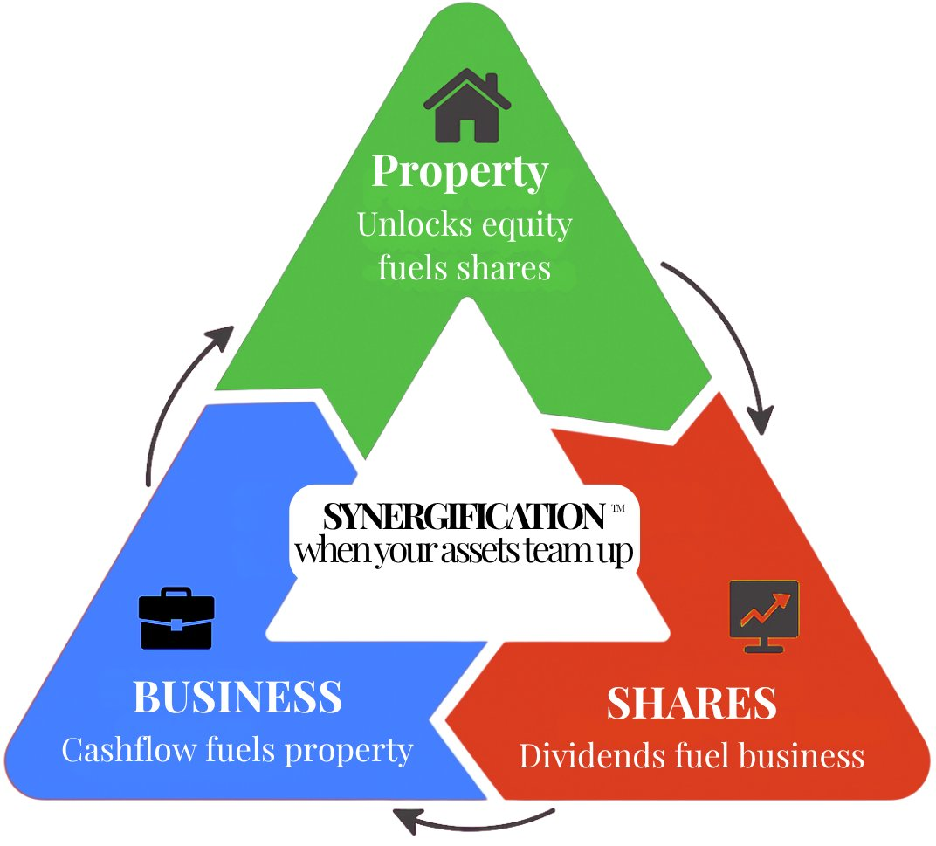

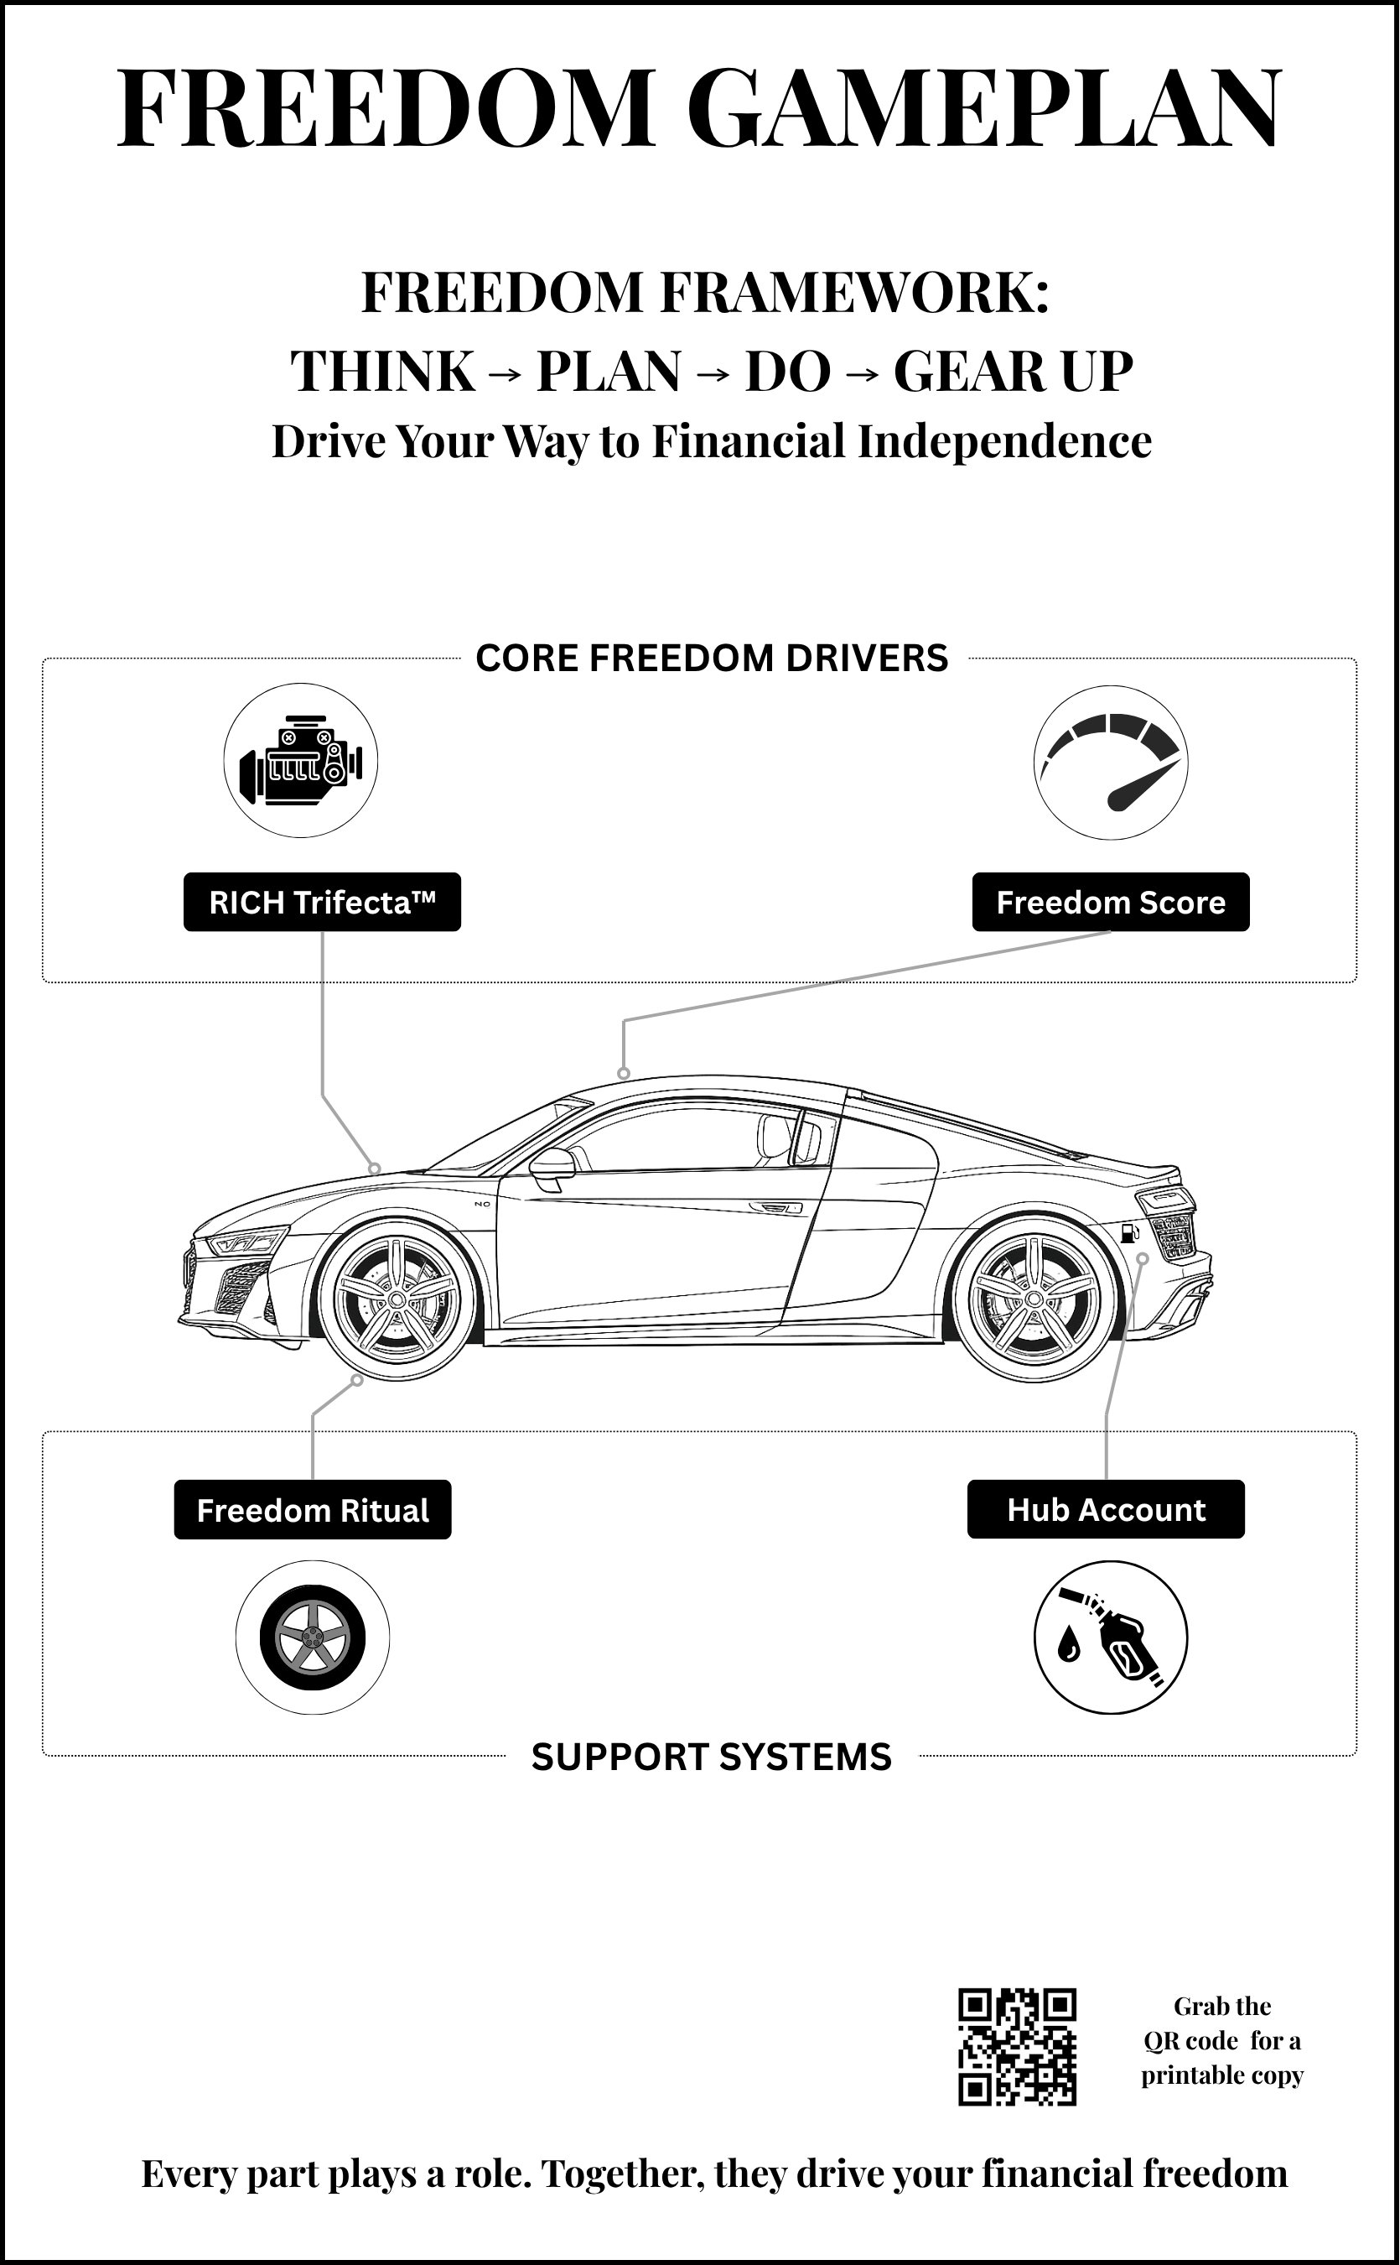
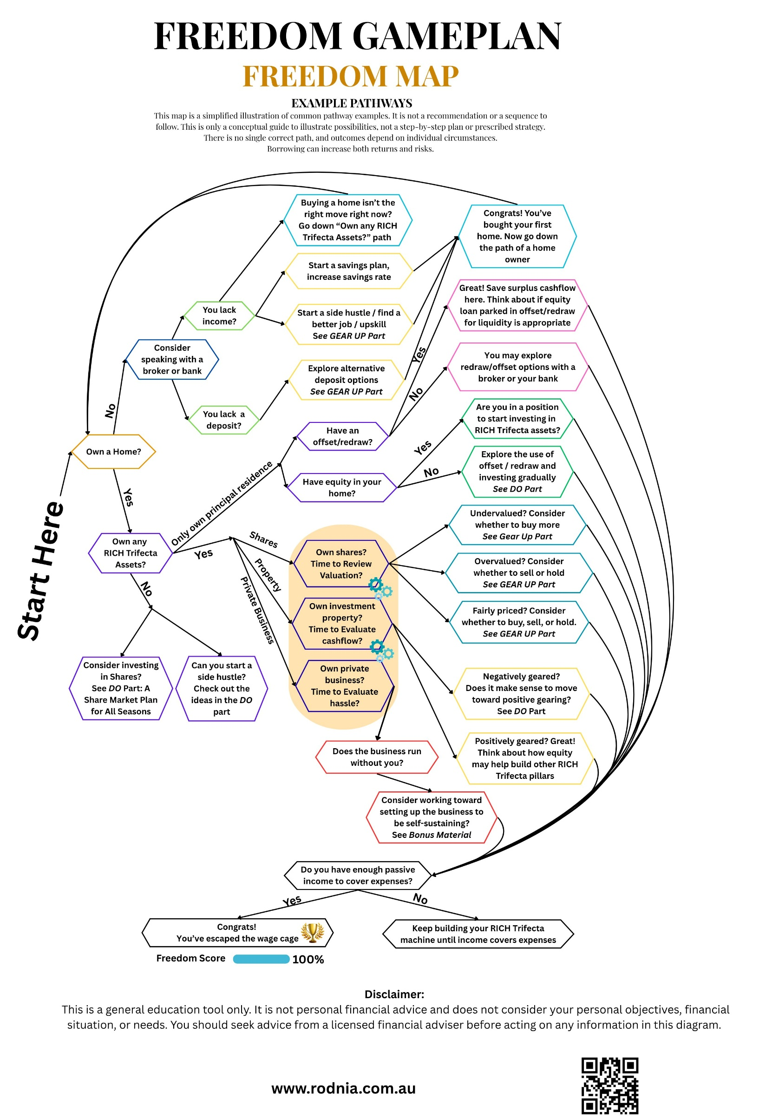

02
4 STAGES OF WEALTH BUILDING
Where are you? Where are you going next?
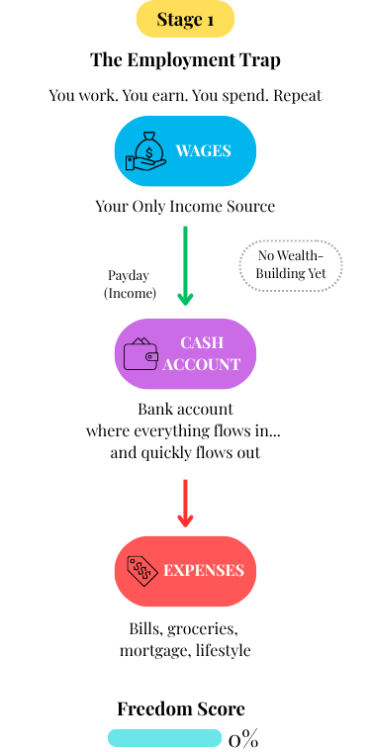
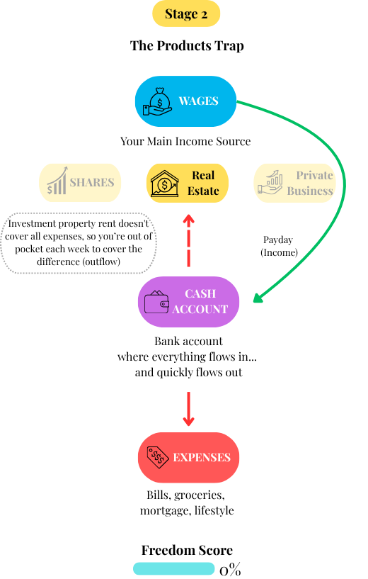

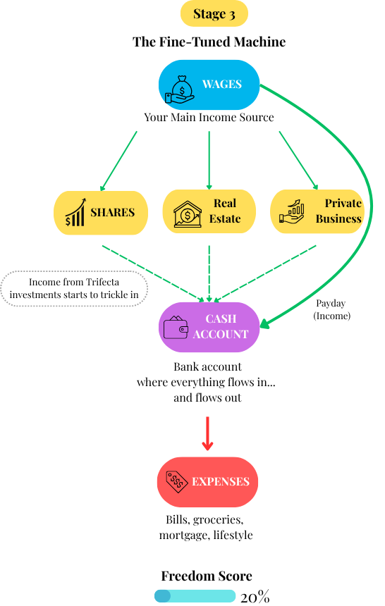

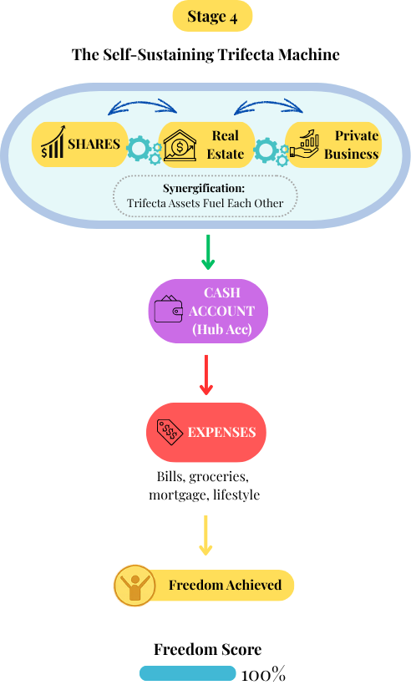
03
WORKSHEETS AND TRACKERS
The tools that turn reading into doing
Your Worksheets and Trackers
Four tools. Each one serves a specific purpose. Use all four and you will have built more financial infrastructure in the next 30 days than most people manage in a year.

▶ SMART Goals Worksheet
Start here. Define what financial freedom actually looks like for you. A goal without specifics is just a wish.
▶ Decision Log
Record every financial decision you make. Patterns emerge quickly. So does accountability.
▶ Freedom Ritual Tracker
Ten weeks. Five minutes per week. Recalculate your Freedom Score, log one decision, share a win. This is the compound interest of good habits.
▶ 30-Day Kickstart
A day-by-day action plan for your first month. The hardest part is starting. This removes that excuse entirely.

Print these. Seriously.
Research shows that writing by hand improves retention and follow-through compared to typing. These worksheets are designed to be printed and filled in with a pen.

SMART Goals Worksheet
Take 10 to 15 minutes. Write down your answers. This is your moment to define what freedom looks like for you.

1. If money were not an issue, how would you spend your time? Think about your ideal day, week, or life rhythm.

2. What are the top three things you want more of in life? E.g., Time? Travel? Security? Purpose? Family?

3. What are you no longer willing to tolerate financially? E.g., Debt? Dependence? Stress? Living pay-to-pay?

4. When you imagine financial freedom, what emotions come up? E.g., Joy? Confidence? Peace? Excitement?

5. What is one bold freedom goal for the next 12 months? Make it SMART: Specific, Measurable, Achievable, Relevant, Time-bound.

Decision Log
Record every financial decision you make, big or small. Patterns emerge quickly. So does accountability. There is no right or wrong entry. Just honest ones.
Note: Use this whenever you make a financial decision, an investment, a purchase you thought twice about, or something you decided not to do. All of those count.

Date | Decision Made | Why I Made It | Outcome | What I Learned

Decision Log (continued)

Date | Decision Made | Why I Made It | Outcome | What I Learned

Freedom Ritual Tracker
Ten weeks. Five minutes per week. Recalculate your Freedom Score, log one decision, and share one win or insight in the FG Community.

Formula: Freedom Score = (Monthly passive income / Monthly living expenses) x 100. If your expenses are $5,000/month and passive income is $1,250/month, your score is 25%. You are in Breakaway territory.

Week | Freedom Score | Date | Key Decision This Week | Win / Insight / Lesson
1
2
3
4
5
6
7
8
9
10

What to share in the FG Community
Your Freedom Score. A decision you made this week. A win, a lesson, or a question. You do not need to share everything. Just one thing. The community is at www.rodnia.com.au/freedomgameplan.

30-Day Kickstart
A day-by-day action plan for your first month. The hardest part is starting. This removes that excuse entirely.
Remember: Do not try to do everything perfectly. Tick the box, note what you did, and move on. If you miss a day, pick up the next. The plan does not expire.

Day | Task / Action
1 | Calculate your current Freedom Score and write it down.
2 | List every income source you currently have: wages, investments, side income.
3 | List every regular expense. Group them: essential, lifestyle, and discretionary.
4 | Identify one expense you could reduce without reducing your quality of life.
5 | Read the section of Freedom Gameplan you found most useful again.
6 | Look up your current super balance and fund. Write it down.
7 | Rest and reflect. What is one thing from this week you want to remember?
8 | Identify which stage of wealth building you are in right now.
9 | Write down one specific financial goal for the next 12 months in SMART format.
10 | Research one side hustle idea from the Side Hustle Library that interests you.
11 | Check your credit score for free via Finder, Credit Savvy, or your bank.
12 | Review your current insurance covers. Are they appropriate for your situation?
13 | Log your first entry in the Decision Log.
14 | Rest and reflect. What is one decision you made this week that moved you forward?
15 | Identify which RICH Trifecta pillar is strongest and which needs the most work.
16 | Research one investment property in a suburb that interests you. Just look.
17 | Find out how much equity you currently have in your home, if applicable.
18 | Set up or review your Hub Account structure.
19 | Book a recurring time in your calendar for your weekly Freedom Ritual.
20 | Share something with the FG Community: a win, a question, or a goal.
21 | Rest and reflect. Recalculate your Freedom Score. Has anything changed?
22 | Identify one financial decision you have been putting off. Take the first step today.
23 | Research one financial adviser or mortgage broker you could speak with.
24 | Read or listen to one book that builds on what you learned in Freedom Gameplan.
25 | Review your estate planning. Do you have a will? An EPOA? Binding super nominations?
26 | Identify one way you could increase your income in the next 90 days.
27 | Write down the three most important financial moves you plan to make this year.
28 | Rest and reflect. What is one belief about money that has changed since you read the book?
29 | Share your current Freedom Score in the FG Community.
30 | Recalculate your Freedom Score. Celebrate any movement. Plan your next 30 days.

That is 30 days done.
Wherever your Freedom Score sits right now, it is higher than it was 30 days ago. Keep the Ritual going. Keep logging decisions. The next 30 days build on these ones. That is how the compound effect of good habits works.

